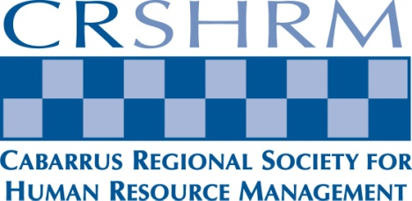

HR Professional Series: ½ Day Workshop

Tuesday, August 9, 2016  
8:00 am – noon

Cabarrus Arena & Events Center  
4751 NC Hwy 49 N

Concord, NC 28025

HR Professional Series: ½ Day Workshop

Come spend your morning with human resources professionals and other business leaders and learn about ways you can make your workplace a better place for your employees. We are very fortunate to have three dynamic speakers who have agreed to come and share their knowledge on topics important to all of us in North Carolina.

CRSHRM Gives Back!

* You will have the chance to bid on many fabulous items donated by local businesses. All proceeds will benefit the SHRM Foundation.
* We will also have a 50/50 Raffle to benefit the SHRM Foundation.
* Don’t forget your checkbook! Cash and major credit cards also accepted.
* We will be collecting school supplies to help local schools assist students as they return to class!

Audience

Human Resources, Benefits and Payroll Professionals, Small Business Owners, any Manager or Supervisor who wants to improve their workplace by using the knowledge and techniques gained in these informative sessions.

3 recertification hours for HRCI and SHRM certifications have been both been submitted, 2 General credits and 1 Business credit

**Think Green!**

Free WIFI… All presentations will be available for electronic download.

Cabarrus Regional SHRM

PO Box 6737

Concord, NC 28027

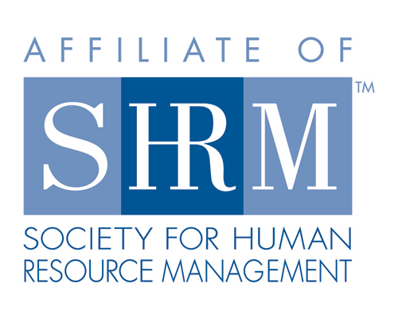

Recipient Name

Street Address

Address 2

City, ST ZIP Code

Agenda

**8:00-8:30am**  
Registration and Full Hot Breakfast  
Vendor Fair and Silent Auction open

**8:30-8:35am**  
Welcome and Housekeeping

**8:35 – 9:35am**  
Kenny Colbert, The Employer’s Association will give us a 2016 Legislative Update

**9:35 – 9:45am**  
Break  
Vendor Fair and Silent Auction open

**9:45 – 10:45am**  
Scott Foster – Heroic Health Care for HR – Proven Practices to Improve Engagement and Results (Strategic credit applied for)

**10:45 – 11:00am**  
Break

Vendor Fair and Silent Auction open

**11:00am – Noon**  
Stan Kimer - “The New Frontier in Workplace Diversity: Supporting Transgender Employees”

**Noon**Closing Remarks, Silent Auction Winners Announced

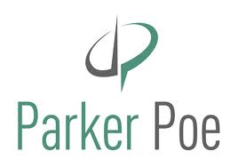  
Our event wouldn’t be complete without sponsors!  
We are happy to have these companies join us!

Sponsors



**C:\Users\mgchopp\AppData\Local\Microsoft\Windows\Temporary Internet Files\Content.Outlook\QZYUE1TF\image001.png**

Additional vendor space available!   
Call us to apply…space is limited!!!

General Information

Registration Fees/Cost:  
 CRSHRM Member Free  
 Non-CRSHRM/ National SHRM $35  
 Non-CRSHRM/ Non- National SHRM $45

**Have Questions?**   
Call Ashley Allen at 704 920-2826 or email [amallen@cabarruscounty.us](mailto:amallen@cabarruscounty.us) or [crshrm@gmail.com](mailto:crshrm@gmail.com)

Registration Form

Name: _____________________________________

Title: ______________________________________

Organization: _______________________________

Address: ____________________________________

____________________________________

Email: ______________________________________

__ CRSHRM Member Free  
__ Non-CRSHRM /National SHRM $35  
__ Non-CRSHRM/Non- National SHRM $45

CRSHRM Members, please RSVP to our Treasurer Ashley Allen [atamallen@cabarruscounty.us](mailto:atamallen@cabarruscounty.us).   
Non-CRSHRM Members please make checks payable to CRSHRM and send with registration form to:   
 **CRSHRM  
PO Box 6737  
Concord, NC 28027**  
For Credit Card payments please contact Ashley Allen at 704 920-2826.  
**Registration Deadline: August 5, 2016**

<https://www.facebook.com/pages/Cabarrus-Regional-Society-For-Human-Resource-Management/132922396762883?fref=ts>

<http://www.linkedin.com/groups?gid=3691630&mostPopular=&trk=tyah>3

[](http://www.google.com/imgres?q=image+of+linkedin+widget&hl=en&rls=com.microsoft:en-us:IE-SearchBox&rlz=1I7_____en&biw=1152&bih=619&tbm=isch&tbnid=St3uxHkq9bspiM:&imgrefurl=http://alternatedesignplumbing.com/post-type-widget-content/find-us-online/attachment/linkedin/&docid=H1zTAWh5fSTYAM&imgurl=http://alternatedesignplumbing.com/wp-content/uploads/2012/05/linkedin.png&w=64&h=64&ei=bEa1T8e7D4Gq2gXzwZQS&zoom=1&iact=hc&vpx=127&vpy=134&dur=235&hovh=64&hovw=64&tx=80&ty=44&sig=100127778839292923806&page=2&tbnh=64&tbnw=64&start=20&ndsp=24&ved=1t:429,r:0,s:20,i:117)[](http://www.google.com/imgres?q=facebook+logo&hl=en&rls=com.microsoft:en-us:IE-SearchBox&rlz=1I7_____en&biw=1152&bih=619&tbm=isch&tbnid=KFICJaE2iv0AvM:&imgrefurl=http://www.simplyzesty.com/facebook/facebook-launches-merge-pages-feature-allows-you-to-grow-fans/&docid=VpNGsuSVQi63mM&imgurl=http://simplyzesty.com/wp-content/uploads//2011/08/facebook-logo.png&w=256&h=256&ei=_ke1T86kM6HL2QWSttgp&zoom=1&iact=hc&vpx=651&vpy=171&dur=734&hovh=204&hovw=204&tx=110&ty=123&sig=100127778839292923806&page=1&tbnh=119&tbnw=120&start=0&ndsp=19&ved=1t:429,r:3,s:0,i:157)<http://cr.shrm.org/welcome-cabarrus-regional-chapter>